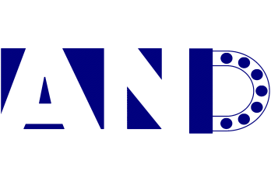
NINGBO AND MACHINERY CO.,LTD
NFTZ AND INTERNATIONAL INDUSTRY&TRADE CO.,LTD

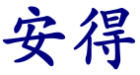
is a bridge links us to the world . Our Chinese name , means in Chinese is “EXPERT in supplying products , be TRUSTED partner to our client “, we stated it as Business Philosophy of my Company when we established it 20years ago .
AND is professional and practiced on basic parts of mechanical power transmission system, One-Stop supplying bearings, shafts, and gears for geared motors, reducers / gear boxes, hydraulic systems (hydraulic pumps and hydraulic motors) and various machinery and equipment. Our parts not only widely exist in traditional mechanical equipment such as construction machinery, mining machinery, agricultural machinery, food machinery, household appliances, machine tools, etc., but also works in new fields such as new energy power generation and new energy vehicles , and other new areas……

Below shows are some of our products :
Bearings :
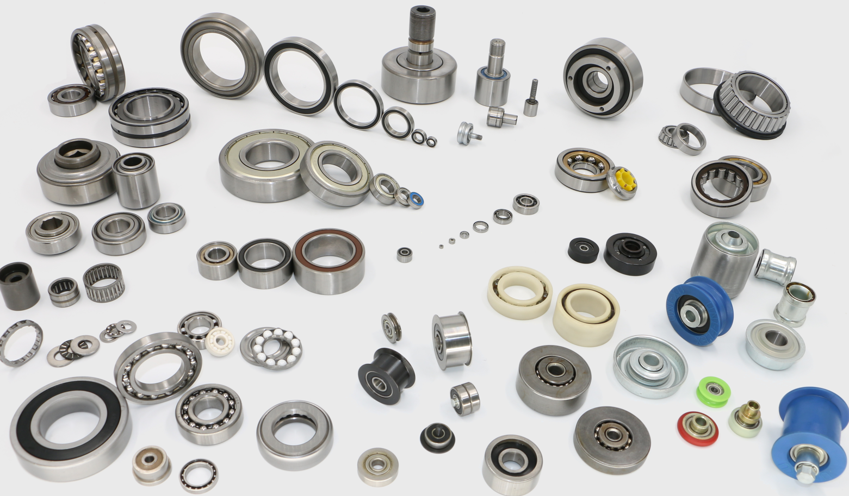
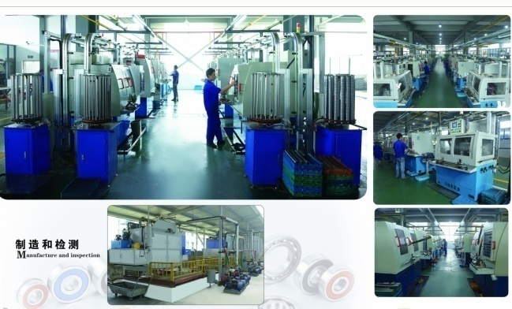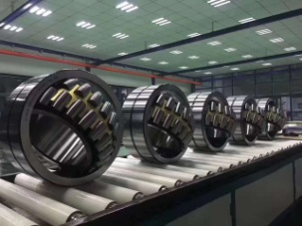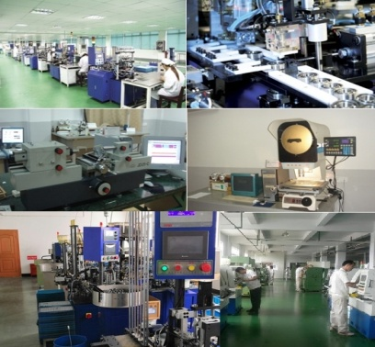

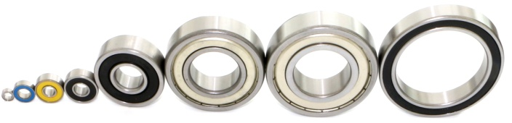
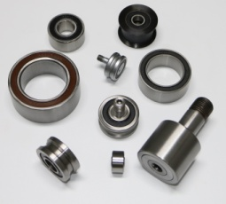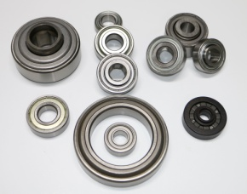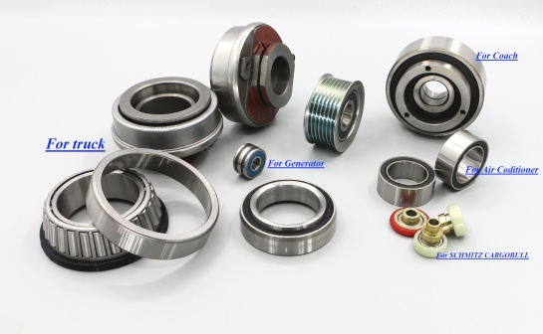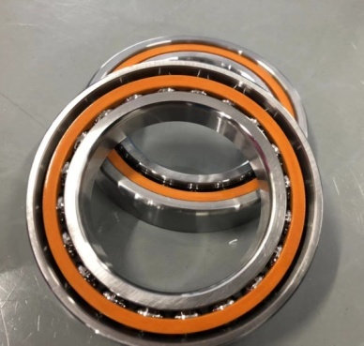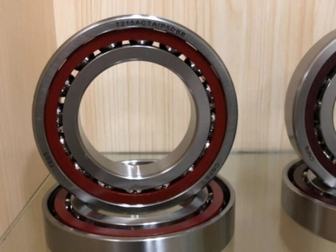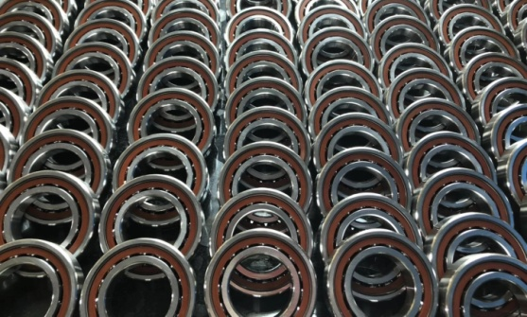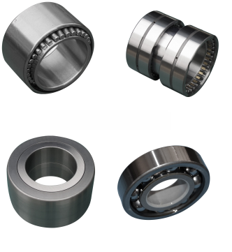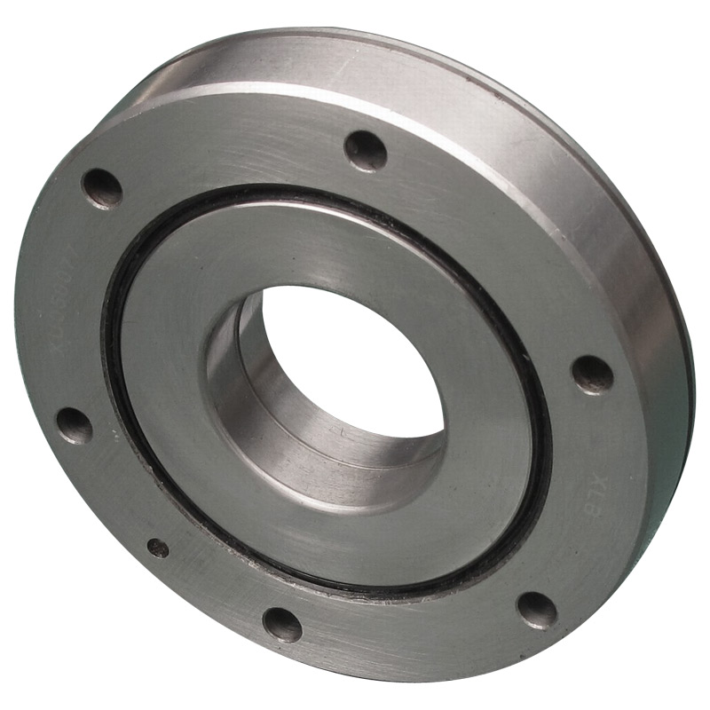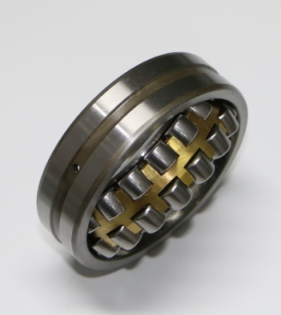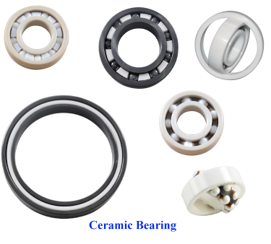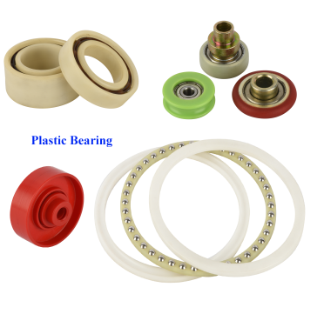
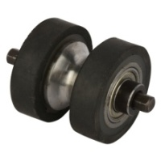
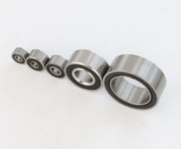
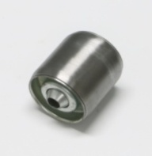
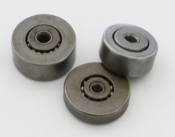

Shafts :

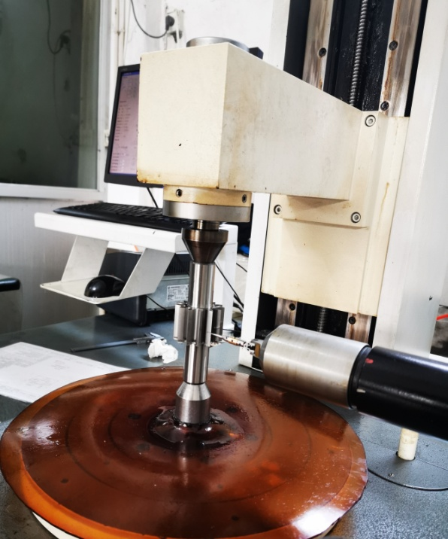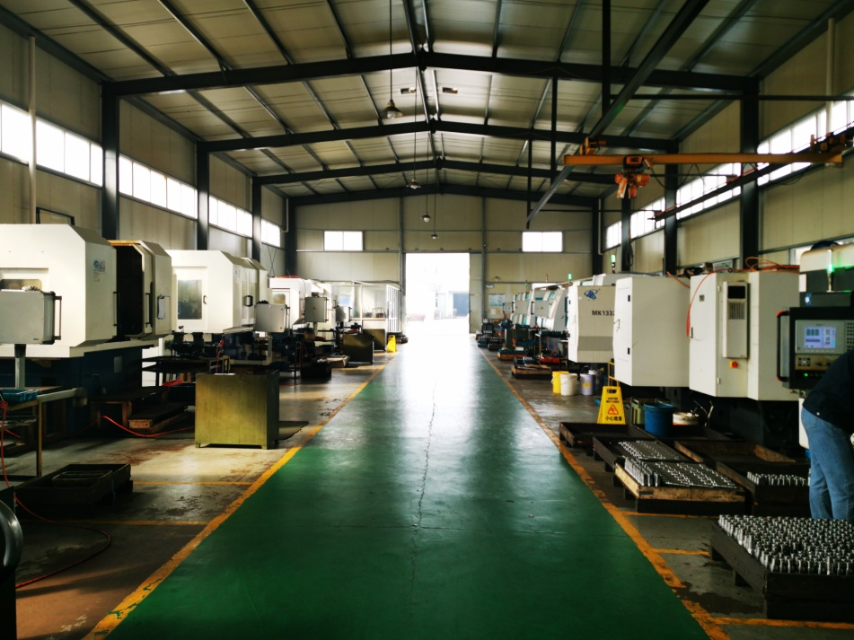

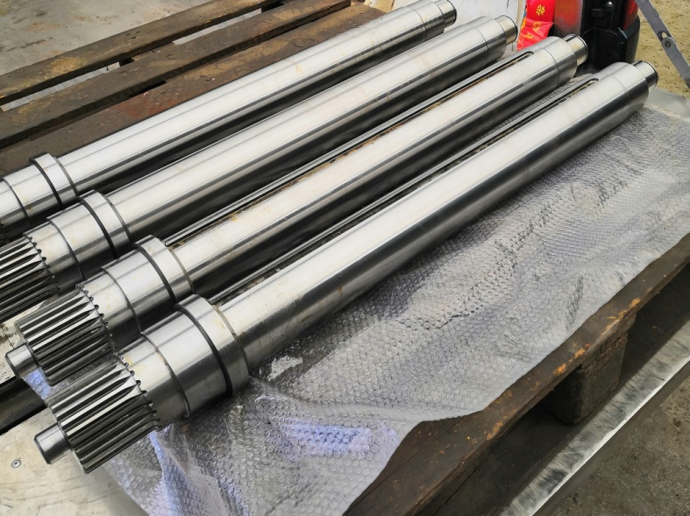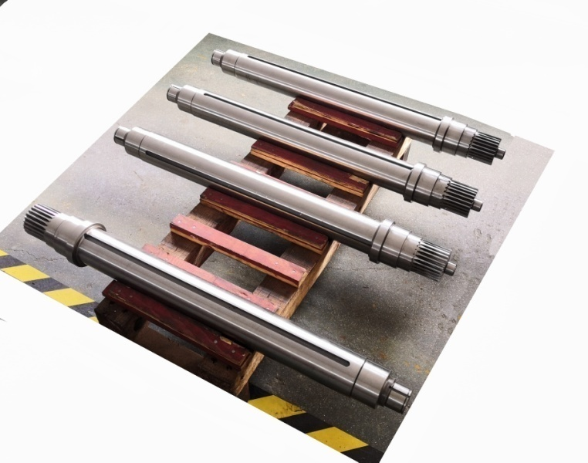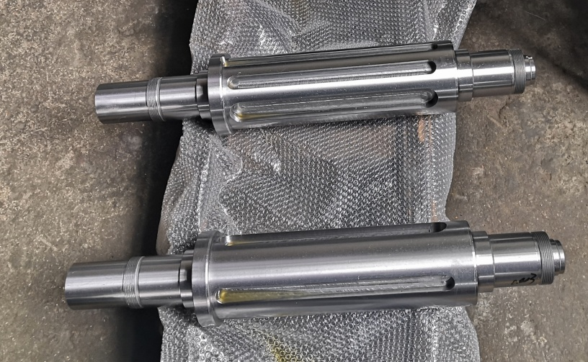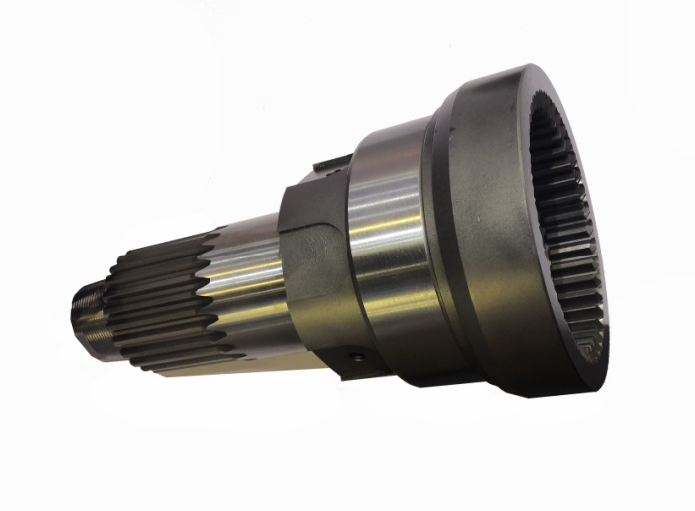
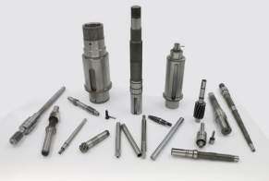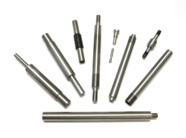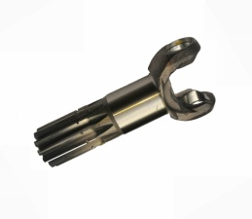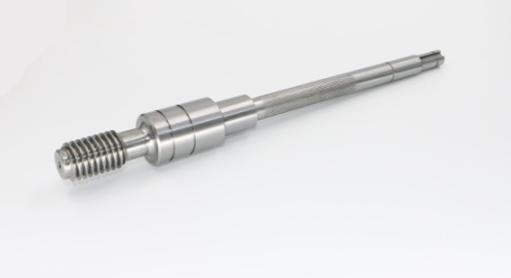
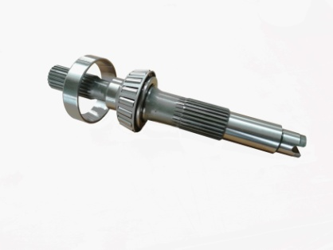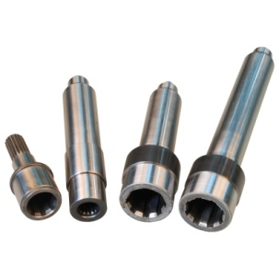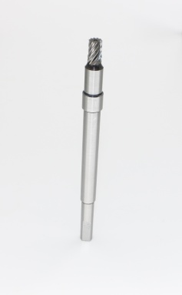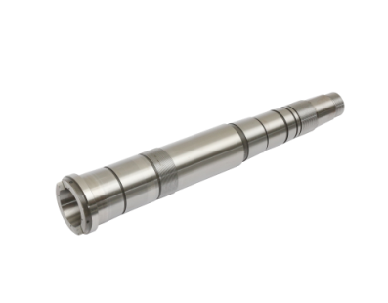
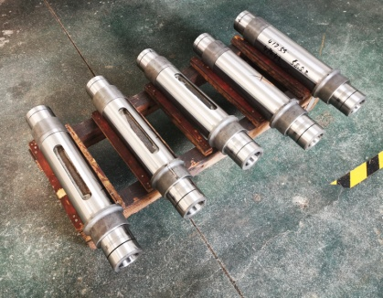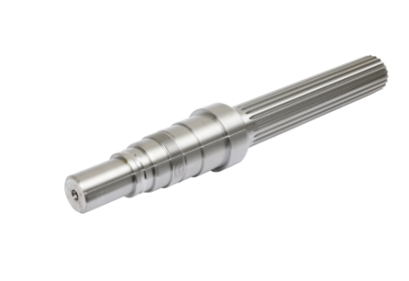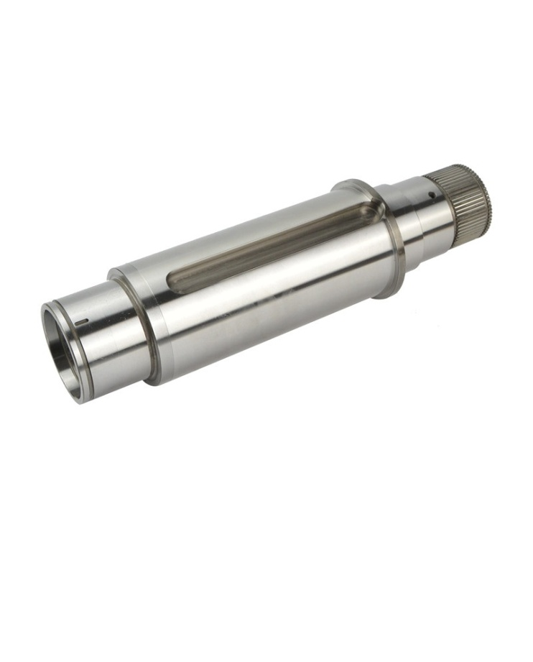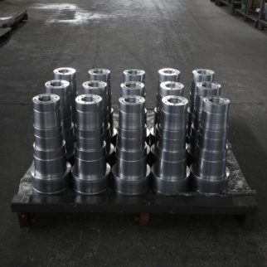Gears
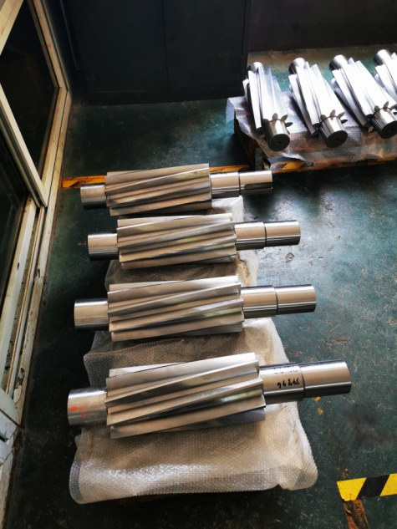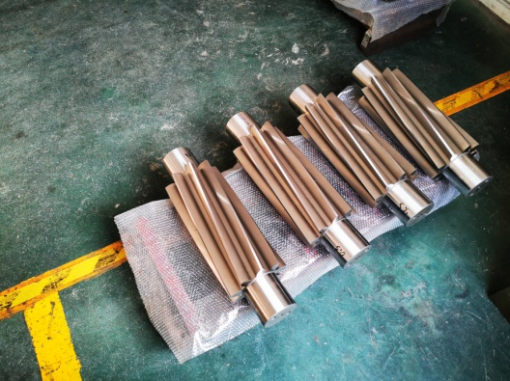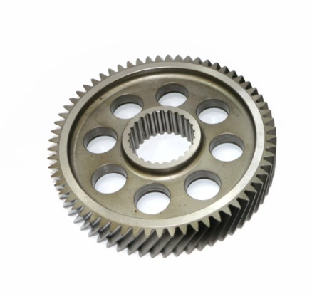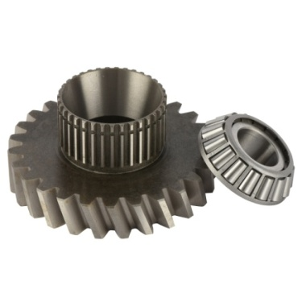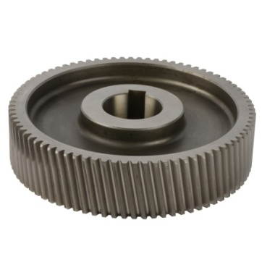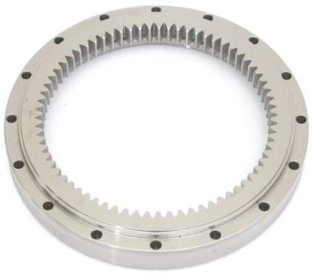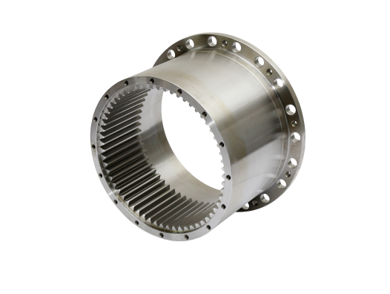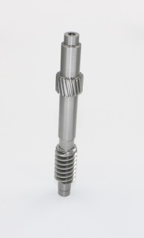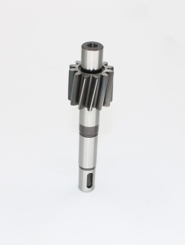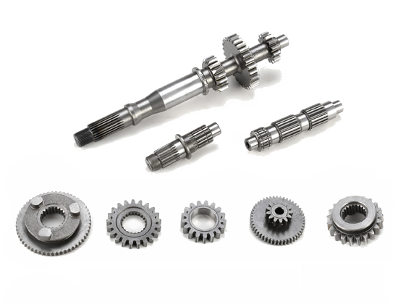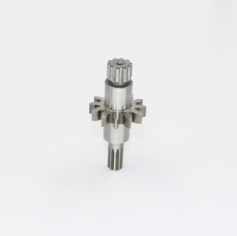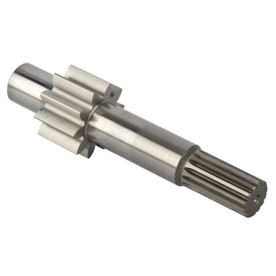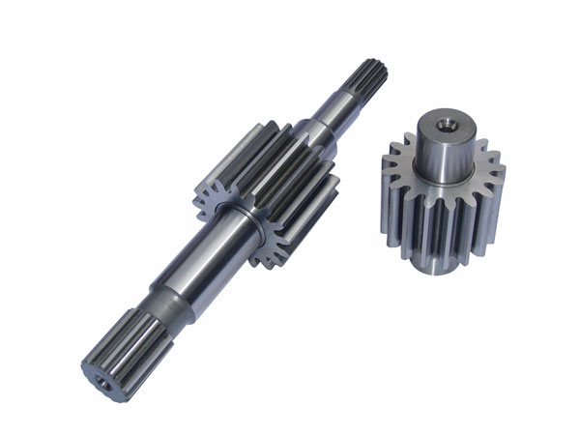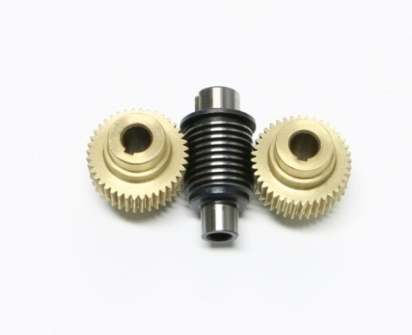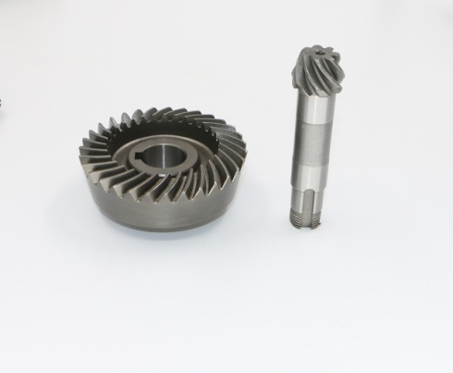

As the basic parts of mechanical transmission, our products are available on all the equipment with rotary parts. Our products are running in every corner of the world with the equipment of various excellent brands, such as 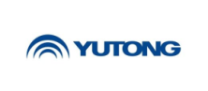Coaches and city bus, 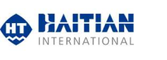Injection Machine, , home electric appliance , 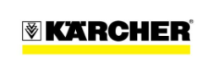Cleaning equipment, ,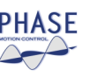Electric motor , ,, construction machine, 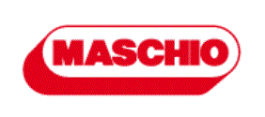 Agricultral machine, Coupling , Hydraulic, 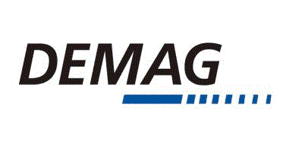crane, , Auto parts , and many other new energy Vihicles , ATV/UTV , Electric bike , Wind power generator………

Bearing is not a universal "general industrial standard parts" as it is simply called , it needs to be professionally designed to coordinate with the shaft, gear and other mechanical parts, also the whole equipment ,the environment should be considered .
In order to design the most suitable bearings for an application it is necessary to conduct a comprehensive study on bearing and the shaft, gear and the housing, the equipment in which the bearing will be installed , consider including operating condition , environment , the performance required of the other components to be installed along with it , marketability , and cost performance , etc.
We have the ability to participate in the discussion on optimal design of transmission parts when clients develop new products, to help speed up the development process
Our well-educated engineers cooperative work with the experts-who with many years of experience in the mechanical processing industry-in workshops,comprehensively consider the balance between product performance and processing capacity/processing costs, that is, to ensure product performance while controlling lower costs;
Each of our manufacturers has specialized products and processes he is good at , which is the most cost-effective - based on this concept, we integrate and manage our supply chain, form a production-sales community. To make every high-quality product, manufacturers in the community cooperates with each other. We, AND, play an important role in the community. We participation makes the communication more smooth and the supply chain runs more efficient and stable. We organize and manage orders according to ISO9000 or IATF16949 quality system—most manufacturers have the certificates , AND is trying to get the certificates soon, strictly control the quality / improve the quality. We turn the customer's requirements, ideas and concepts into reality, make the products more competitive and help my client successful.
Three parties , manufacturers-we, AND,-foreign clients in terms of engineering/quality control & improvement/cost control form complementary relationship during cooperating , we are win-win.
We have established firm cooperative relationship with clients all over the world in the past 20 years , built good reputation depends on our professional technical ability and perfect service.
We are unsung heroes, supporting machines running in every corner of the world.
Drop me an opportunity to become a trusted partner to you !

Almost all our products are customized for each customer.
Please contact us if you demand on transmission parts :
Tel.: 0086-574-8714 9648 , 8712 1096 0086-137 7712 0064 , 139 5740 0944
Mail: tech@and-china.com , info@and-china.com

